**ACTIVITY – 2**

**Following are the Non – Biodegradable materials:**

1. **Paper:**

The decay process of paper involves the action of microorganisms, such as bacteria and fungi, that feed on the cellulose fibers in the paper. Paper is made up of cellulose fibers that are held together by lignin and other chemicals. When paper is exposed to microorganisms such as bacteria and fungi, they begin to feed on the cellulose fibers in the paper. The microorganisms produce enzymes that break down the cellulose fibers into smaller molecules. As the microorganisms feed on the cellulose fibers, they produce organic compounds such as carbon dioxide and water. Over time, the cellulose fibers in the paper are broken down into smaller and smaller pieces until they are no longer visible. The organic compounds produced by the microorganisms are absorbed by the environment.

The use of paper has a significant impact on the environment and ecology. Here are some issues associated with paper production and use that are Deforestation, Energy consumption, Water consumption

1. 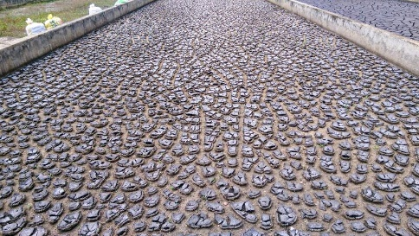**Sewage sludge:**

The decay process of sewage sludge involves the action of microorganisms that break down the organic matter in the sludge. Sewage sludge is a semi-solid waste material that contains a high concentration of organic matter. When sewage sludge is treated, microorganisms such as bacteria and fungi are introduced to the sludge. The microorganisms in the sewage sludge produce enzymes that break down the organic matter in the sludge into smaller molecules. As the microorganisms feed on the organic matter in the sludge, they produce organic compounds such as carbon dioxide and water. Over time, the organic matter in the sewage sludge is broken down into smaller and smaller pieces until it is no longer visible. The organic compounds produced by the microorganisms are absorbed by the environment.

Here are some of the issues associated with sewage sludge that are Landfills, Soil contamination, Nutrient loading

1. 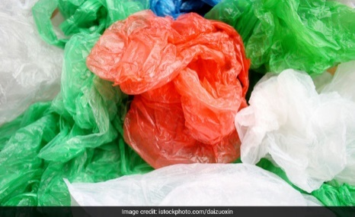**Polythene:**

The decay process of polythene involves a combination of physical and chemical degradation. Exposure to sunlight, heat, and oxygen can cause the polythene to break down and become brittle over time. This process is known as photo-oxidation. The broken-down polythene can then be further degraded through chemical processes such as hydrolysis, which involves the breaking down of the polymer chains in the presence of water. This can result in the formation of smaller compounds, such as carbon dioxide and water, that can be absorbed by the environment.

Here are some of the issues associated with polythene thar are Marine pollution, Fossil fuel use, Microplastic pollution

**Following are the Biodegradable materials with their levels of decay and natural decay process:**

1. 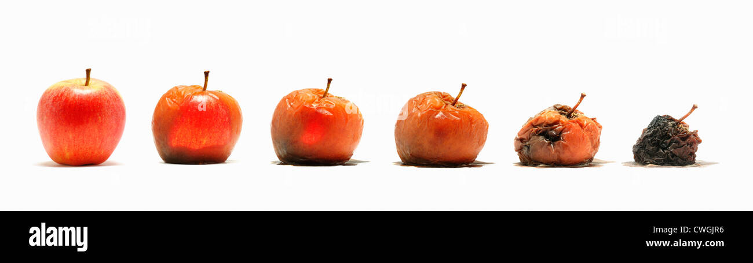**Apple**

The degree of decay of an apple can vary depending on several factors, such as the type of apple, environmental conditions, and the presence of microorganisms. The degree of decay of an apple can be assessed by examining its physical appearance and texture. An apple that is severely decayed may be soft, mushy, and discoloured, with visible mould or fungal growth. In contrast, a slightly decayed apple may have softer areas or slight discoloration but still maintain its overall shape and texture.

As an apple starts to decay, it may develop brown or soft spots, become mealy or mushy, and may emit a musty or unpleasant odour. If left for too long, the apple may completely rot and become inedible.

1. **Potato**

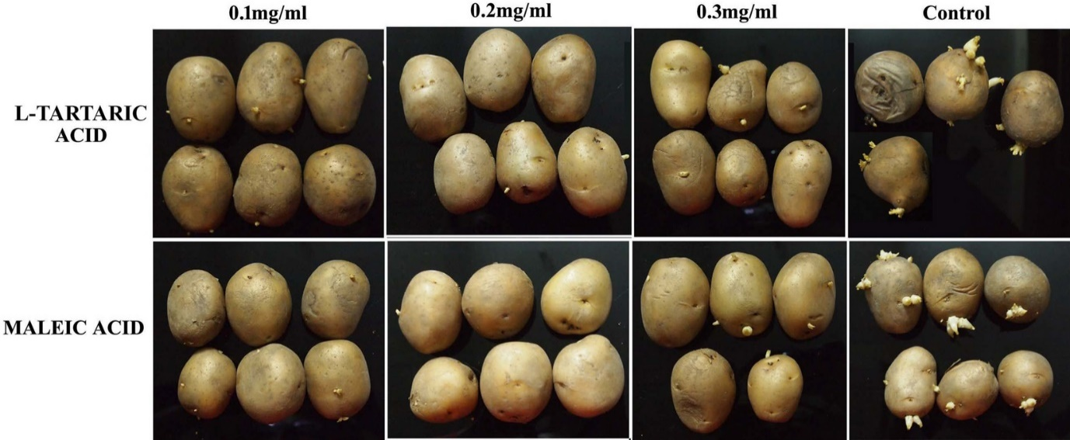

The degree of decay of a potato can vary depending on several factors, such as the type of potato, environmental conditions, and the presence of microorganisms. The degree of decay of a potato can be assessed by examining its physical appearance and texture. A severely decayed potato may be soft, mushy, and discoloured, with visible mould or fungal growth. In contrast, a slightly decayed potato may have softer areas or slight discoloration but still maintain its overall shape and texture.

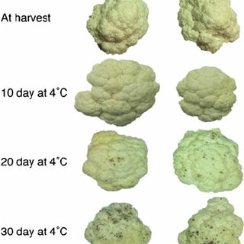As a potato starts to decay, it may develop soft or mushy spots, sprouts, and may emit a musty or unpleasant odour. If left for too long, the potato may completely rot and become inedible.

1. **Cauliflower**

The degree of decay of a cauliflower can vary depending on several factors, such as the freshness of the cauliflower, environmental conditions, and the presence of microorganisms. The degree of decay of a cauliflower can be assessed by examining its physical appearance and texture. A severely decayed cauliflower may be soft, mushy, and discoloured, with visible mould or fungal growth. In contrast, a slightly decayed cauliflower may have softer areas or slight discoloration but still maintain its overall shape and texture.

As cauliflower starts to decay, it may develop brown or black spots, become slimy, and emit a sour or unpleasant odour. If left for too long, the cauliflower may completely rot and become inedible.

1. 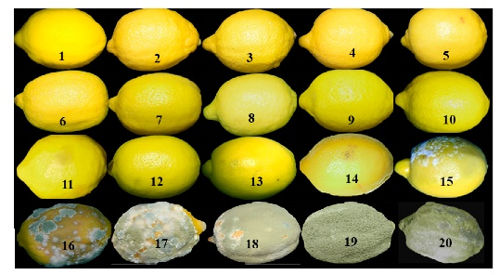**Lemon**

The degree of decay of a lemon can vary depending on various factors such as its age, ripeness, storage conditions, and exposure to air and moisture. Over time, a lemon will begin to lose its firmness and moisture, and the skin may become softer and wrinkled. The colour may also change from bright yellow to a more dull or brownish colour.

As a lemon starts to decay, it may develop mould, become slimy, and emit a sour or unpleasant odour. If left for too long, the lemon may completely rot and become inedible.

1. **Human Tooth/ Flesh**

The degree of decay of human teeth and flesh can vary depending on various factors, including the conditions in which they are kept and the length of time since death. After death, the body undergoes a process called decomposition, which involves the breakdown of tissues by bacteria and enzymes. This process can begin within hours of death and can continue for weeks or months.

In the case of teeth, decay can occur due to poor oral hygiene, bacterial infection, or other factors. As decay progresses, the affected tooth can become discoloured, weakened, and painful. If left untreated, the tooth can eventually become infected, leading to further decay and potential health complications.

In the case of flesh, the degree of decay can be measured using the stages of decomposition. The stages of decomposition include fresh, bloat, active decay, advanced decay, and dry remains. During these stages, the body undergoes various changes such as bloating, discoloration, and the release of foul odours. Eventually, the body will dry out, and the remains will be reduced to bones.

**Following are the observations on when we add a catalyst salt and rock salt on following items:**

* Apple: The apple placed in the container with white salt showed signs of decay within a few days, whereas the apple in the container with rock salt took slightly longer to show signs of decay.
* Potato: The potato placed in the container with white salt showed signs of decay faster than the one in the container with rock salt.
* Cauliflower: The cauliflower placed in the container with white salt showed signs of decay within a few days, whereas the one in the container with rock salt took longer to show signs of decay.
* Lemon: The lemon placed in the container with white salt showed signs of decay within a few days, whereas the one in the container with rock salt took slightly longer to show signs of decay.
* Human Tooth/Flesh: We did not perform this experiment as it is not ethical to use human remains for scientific observation.

**Following are the references that are taken through internet are:**

dreamstime.com, sciencefocus.com, ndtv.com, alamy.com, nature.com, researchgate.net, mdpi.com